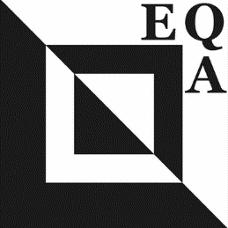 | EUROPEAN QUILT ASSOCIATION  EQA Challenge 2026  The Fantastic World of Insects  The purpose of the European Quilt Association is to promote quilting across borders, cultures and language barriers.While our mission highlights the similarities we share through our love of quilting, this year’s challenge invites us to celebrate diversity by turning our attention to a fascinating subject: Insects.

RULES
- Insects are the most diverse group of animals, with more than a million species; they represent more than half of all animal species. They may be small in size, but they play vital roles in our world: pollinating plants, enriching ecosystems, and even inspiring art and design. Upon closer inspection, they reveal an extraordinary variety of lines, shapes, colours, and textures, offering endless inspiration for creative interpretation. Through this challenge, we encourage guild members to look beyond first impressions and explore the hidden beauty of insects. Whether delicate or bold, realistic or abstract, let your quilt capture the wonder of these remarkable creatures and showcase how diversity enriches both nature and our quilting community. From tiny wings to intricate patterns, may your quilts reveal the hidden wonders of the insect world.
- Any technique or style may be used. Avoid making 3D quilts, and using heavy or fragile materials since the pieces will be travelling throughout Europe.
- Binding: in accordance with the style of the quilt as long as the size requirements are followed
- Dimensions: 35 by 35 cm (square). Do not have any pieces hanging from your quilt, as they may get damaged during transportation and storage.
- The quilt should be single sided, and with a minimum sleeve width of 7 cm. The sleeve should be attached 1 cm from the top edge, and 2 cm from the sides. Proposed dimensions of the sleeve are 31cm long by 7cm wide.
- The label on the back should contain the artist’s name, title of the quilt, the email address and the country of origin.
- All guild members may participate with one piece of work, and there is no entry fee. The quilts are not for sale.
- It is expected that full images of quilts are not shared in any public/social forum prior to the EQA Facebook posting. Photos of the quilts may be used by the EQA for publicity purposes.
- The collection of the quilts will be exhibited at a variety of quilting events in the EQA member countries.
- Register your interest to participate with your EQA Representative by sending your name, address, e-mail either electronically or by mail on or before January 31, 2026. (This may be done using guild websites where available.)
- By participating you recognize that the participants will be at all levels of expertise. The reward for participating is the experience of connecting with other European quilters.

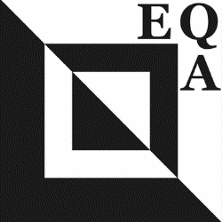 | EQA Challenge 2026  The Fantastic World of Insects

ENTRY FORM

NAME Tel. no/Mobile.
ADDRESS E-mail

YOUR GUILD NUMBER

Name of the quilt in your own language:
Name of the quilt in English:

- I HAVE READ THE RULES AND AGREE TO THE CONDITIONS.

SIGNED DATE

Please send the entry form by January 31st 2026.

Please send a picture of your finished quilt by May 31^{st,} 2026. Previously delivered photos may be used in announcements or advertisements.

The finished quilts are to be delivered by your EQA Representative by June 15th , 2026.

International Representative

