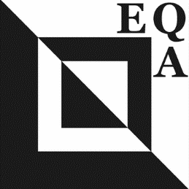 | EUROPEAN QUILT ASSOCIATION  EQA Challenge 2024  “Imagine a Bird”  The purpose of the European Quilt Association is to promote quilting across borders, cultures and language barriers. EQA will have its 35th birthday in 2024, and is hoping to celebrate with a large and festive collection of bird quilts. Whether real or imaginary, birds should have a small bit of emerald, which is a common material to mark 35th anniversaries.

RULES
- The quilt will be associated with birds, whether real or imaginary, whether full body or just a part, whether alone or in groups.
- The quilt should contain an about 1” square of emerald fabric.
- Any technique or style may be used. Avoid making 3D quilts, and using heavy or fragile materials since the pieces will be travelling throughout Europe.
- Binding: in accordance with the style of the quilt as long as the size requirements are followed Dimensions: 35 by 35 cm (square).
- The quilt should be single sided, and with a minimum sleeve width of 7 cm.
- The label on the back should contain the artist’s name, title of the quilt, the email address and the country of origin.
- All guild members may participate and there is no entry fee. The quilts are not for sale.
- It is expected that full images of quilts are not shared in any public/social forum prior to the EQA Facebook posting. Photos of the quilts may be used by the EQA for publicity purposes.
- The collection of the quilts will be exhibited at a variety of quilting events in the EQA member countries.
- Register your interest to participate with your EQA Representative by sending your name, address, e-mail either electronically or by mail on or before January 31, 2024. susan@patchquilt.ch or info@patchquilt.ch
- By participating you recognize that the participants will be at all levels of expertise. The reward for participating is the experience of connecting with other European quilters.

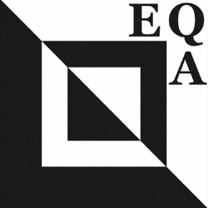 | EQA Challenge 2024  “Imagine a Bird”

ENTRY FORM

NAME Tel. no/Mobile.
ADDRESS E-mail

YOUR GUILD NUMBER

Name of the quilt in your own language:
Name of the quilt in English:

- I HAVE READ THE RULES AND AGREE TO THE CONDITIONS.

SIGNED DATE

Please send the entry form by January 31st 2024.

Please send a picture of your finished quilt by May 31^{st,} 2024. Previously delivered photos may be used in announcements or advertisements.

The finished quilts are to be delivered by your EQA Representative by June 15th , 2024.

International Representative

